The Orange Battles of Ivrea
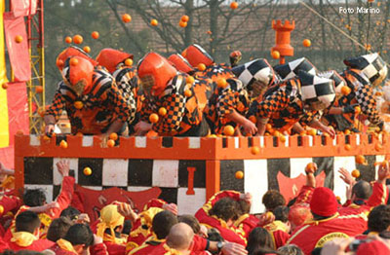
The traditional orange throwing has its roots in the middle of the 16th century. Earlier in the middle ages, beans were used in this battle. We are told that twice a year the feudal lord gave a pot of beans to the poor families who, out of disrespect, threw them into the streets. The same pulses were also used at carnival as fun ammunition to be thrown at the backs of unsuspecting adversaries. Around the thirties of the last century, girls started to throw oranges from their balconies onto the parade carriages together with confetti, lupins and flowers.
The targets of these were the boys by whom the girls wanted to be noticed. From the carriages the boys started to answer in kind and little by little, the tradition grew and grew to become the famous festival that it is today.
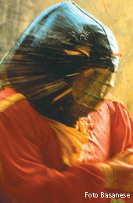
Today the contest is still enacted in the main squares of the town where teams in carriages (symbolising the tyrant’s guards) battle against the orange thrower teams on foot (the rebellious commoners) which consist of hundreds of throwers.
Undoubtedly this is the most spectacular event of the festivities representing the fight for liberty, the symbol of the Ivrea Carnival.
The orange battle is an incredible cultural event putting the festival on a national and international level. The orange throwing is also the event with the greatest collective participation: anybody can take part by enlisting in one of the nine teams on foot or becoming a member of a carriage crew.
From http://www.carnevalediivrea.it/english/battaglia.asp

Find words or expressions in the article which mean the same as:

Dates back to (v)
Something fired or thrown as a weapon (n)
Not knowing something (adj)
Enemies (n)
To return the gesture even more than it was offered (v)
Acted out (v)
Bad person (n)
Common working people (n)
People taking part together (n)

Now answer these questions:

- When did the tradition of orange throwing begin?
- How have the weapons changed over the years?
- What was the ultimate intention of the first people to throw oranges?
- All considered, what does the carnival symbolise?
- Who can take part in this festival?

